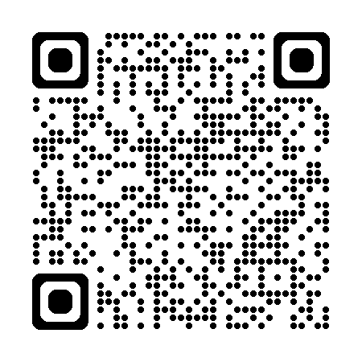  IndivisibleFitchburgMA.org | IndivisibleFitchburgMA.org | IndivisibleFitchburgMA.org
IndivisibleFitchburgMA.org | IndivisibleFitchburgMA.org | IndivisibleFitchburgMA.org
IndivisibleFitchburgMA.org | IndivisibleFitchburgMA.org | IndivisibleFitchburgMA.org
IndivisibleFitchburgMA.org | IndivisibleFitchburgMA.org | IndivisibleFitchburgMA.org

